**QSMART – LED CCA REPLACEMENT**

**PROCEDURE**

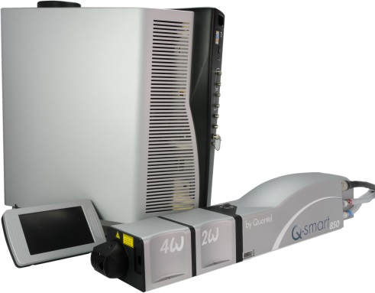

**Toolkit:**

Allen keys

**System**: QSMART

|  |  |  |  |  |  |  |  |  |  |  |
| --- | --- | --- | --- | --- | --- | --- | --- | --- | --- | --- |
| |  |  | | --- | --- | | **SM010351** | **Q-SMART LED CCA** | | | | | |  |  |  |  |
|  |  |  |  |
|  |

**Purpose**: This document details how to change the LED Card

|  |  |  |
| --- | --- | --- |
| Revision | date | modification |
| Initial issue | July 4, 2014 |  |
| revB | November 28, 2014 | CCA LED adds harness and require procedure modification |
|  |  |  |
|  |  |  |

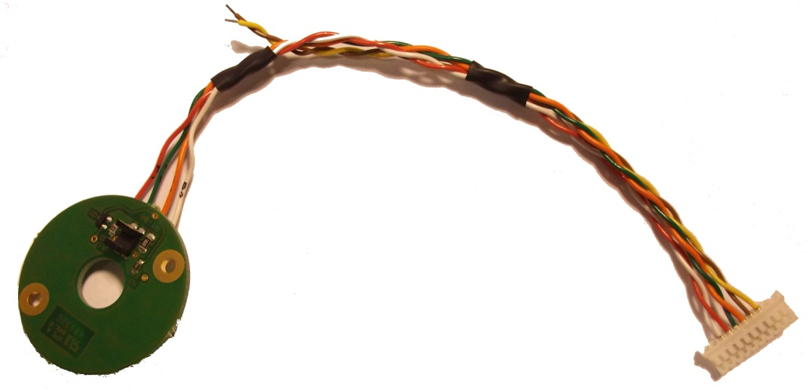

# DISASSEMBLING

* Turn the system off
* Disconnect cables and water hoses from the side of the laser head
* Remove the laser head cover.
* Remove the side plate (7 BHC 3x6)
* Remove the two UNC 4-40 long ¼ 3/E13/0601 screws on the front panel

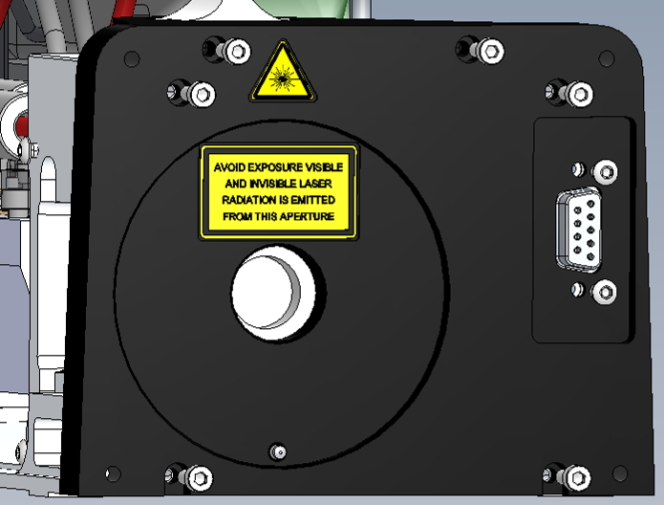

Connector attachment face avant

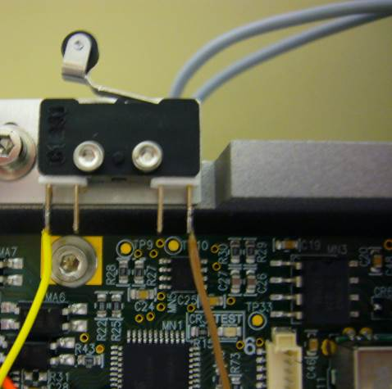

* Unsolder yellow and brown wires of the LED card on external contacts of the switch.

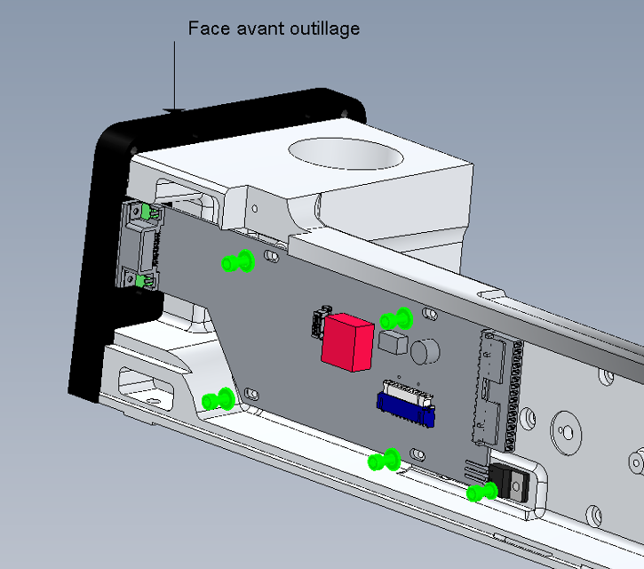

Transistor

* Disconnect the LED cable (J3) from the LB card
* Unscrew the screws holding the LB card (5 screws CHC3X6 + 4 MU3 washers).
* Remove temperature sensor, refer to “LH - SM010350- TEMP SENSOR ASSY”.

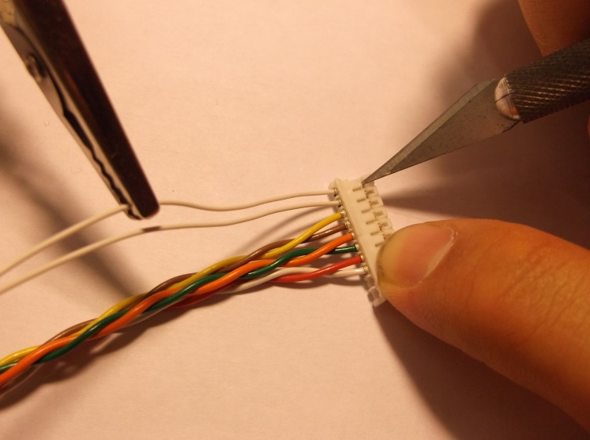

* Extract 2 temperature sensor wires from white connector (see photo)

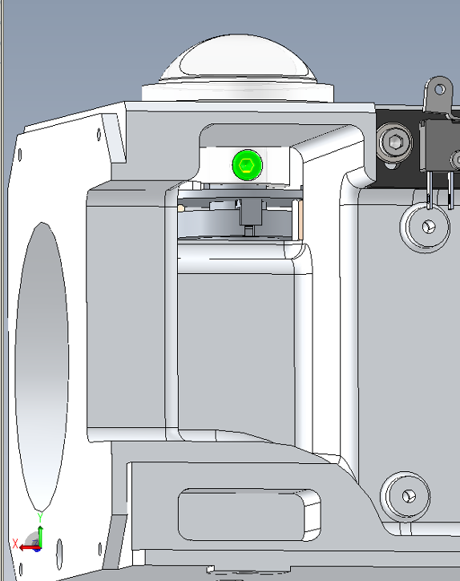

* Remove the manual shutter 3/PLA1294 by unscrewing the screw CHC 3x6.

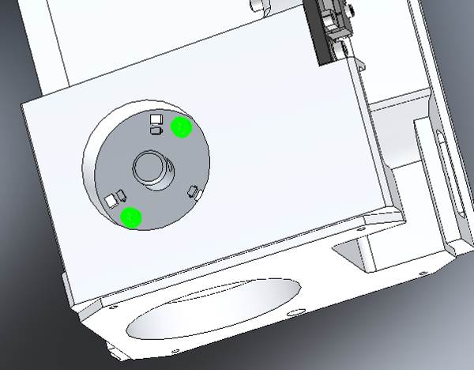

* Remove the 4/300/1057 LED card by unscrewing the 2 screws CHC 3x5 +2 washers

# IMPLEMENTATION OF THE LED CARD



* Insert the LED Card 4/300/1057 (you may have to deburr the edges) and fasten it (2 CHC 3x5 screws +2 ZU3 washers).
* Make sure that the axle pin rotates correctly.

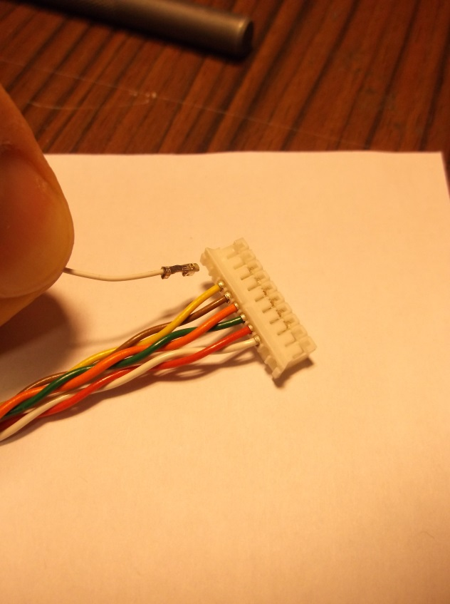

* Insert 2 temperature sensor wires into the white connector.



* Fasten the manual shutter 3/PLA1294 (1 CHC 3x6screw)
* Check the proper functioning of the shutter.
*  Pass the LED card wires below the LB card 4/300/1036. (refer to the picture)

Transistor

* Fasten with 4 CHC 3x8 screws + 4 M3U washers without tightening
* Connect the LED cable on the LB card (J3).
* Install the LB card connector on the front and tighten each screw.
* Fasten the transistor to the card with a CHC 3x6 screw + ZU3 washer.
* Weld the three pins of the transistor.
* Insert back the temperature sensor on head casting

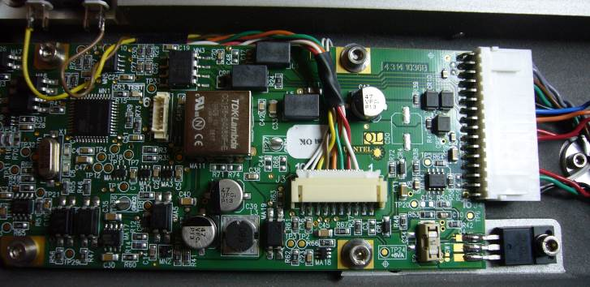

Wires



* Weld the yellow and brown wires of the LED card on external contacts of the switch.
* Screw the 2 4-40 UNC long 3/E13/0601 ¼ screws on the front panel



Connector attachment face avant

* Close the Laser head and put warranty stickers   
  *Refer to "LH-Warranty Labels"*